AMI-AMAZON MACHINE IMAGE

Amazon machine image is used for creating your own software with the configurations that you needed and after creating this AMI’s you can sell that in the “AWS MARKET PLACE” .Like this also you can show case your skills and earn money

Lets see the practical session on the AMAZON MACHINE IMAGE

Go to instance module

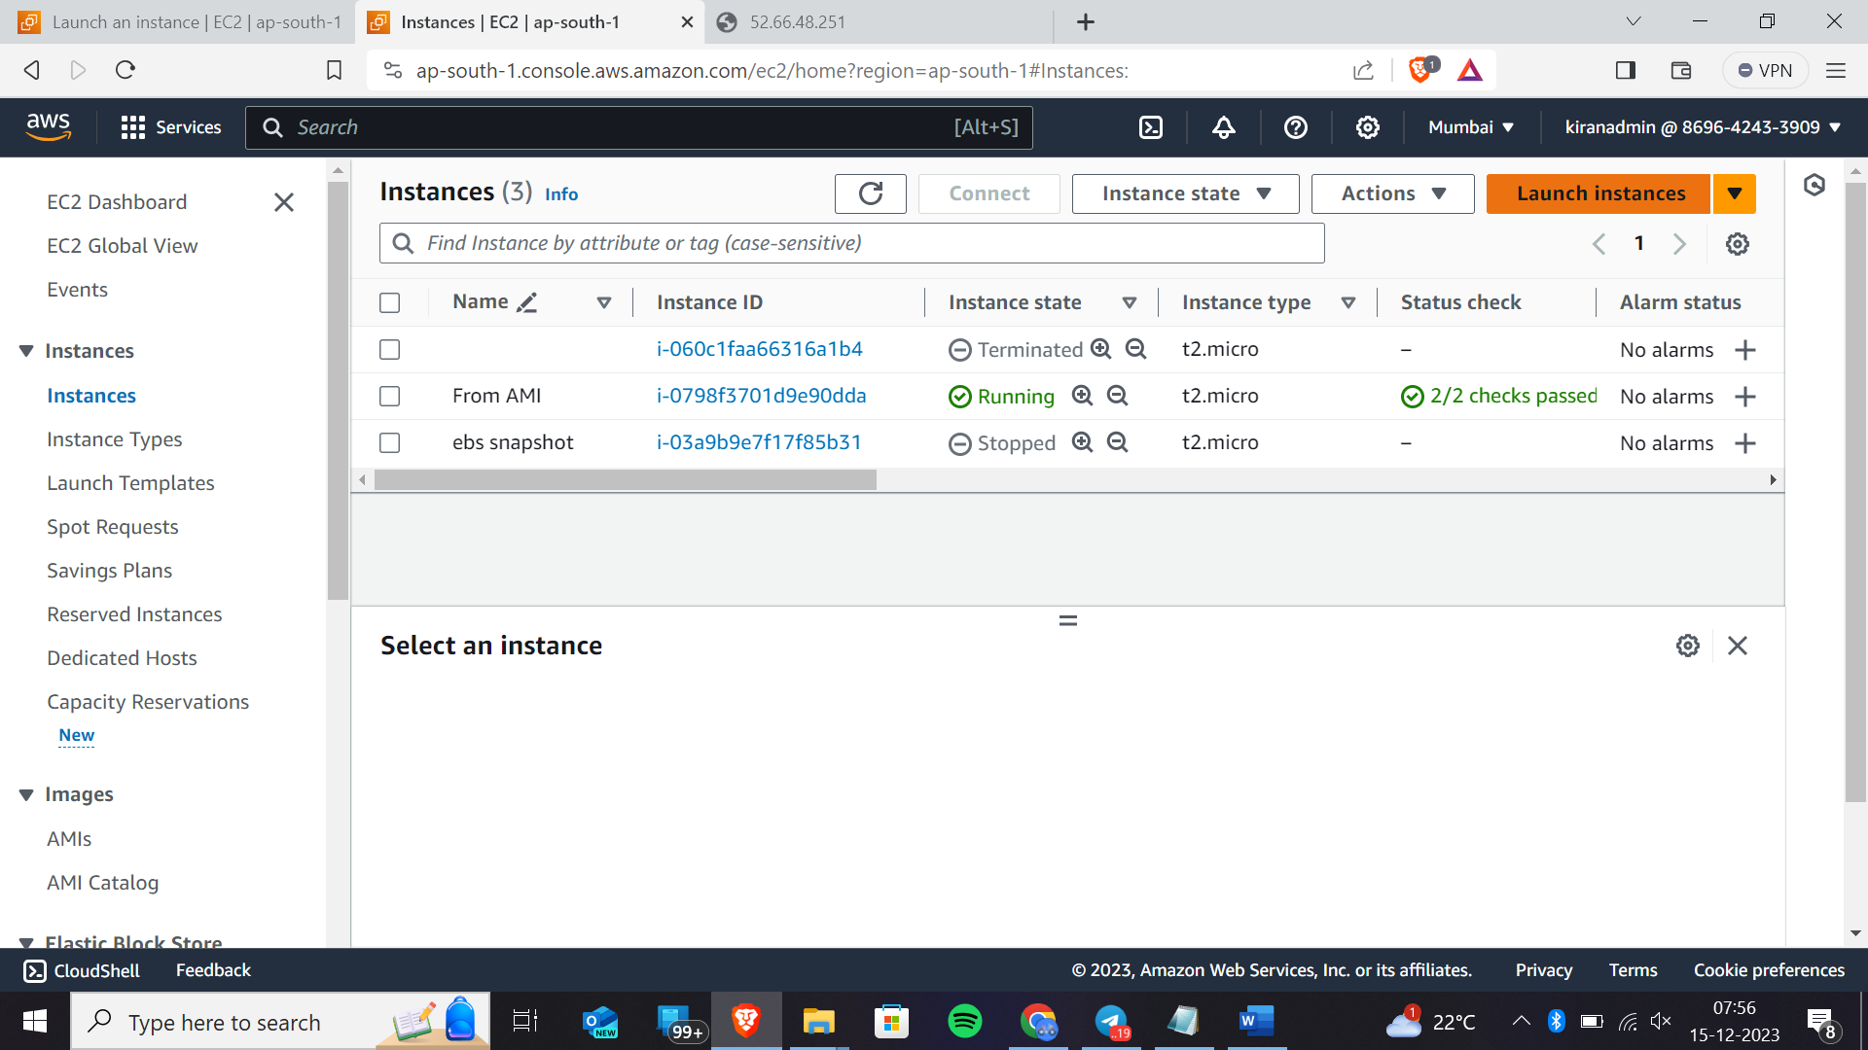click on launch instances

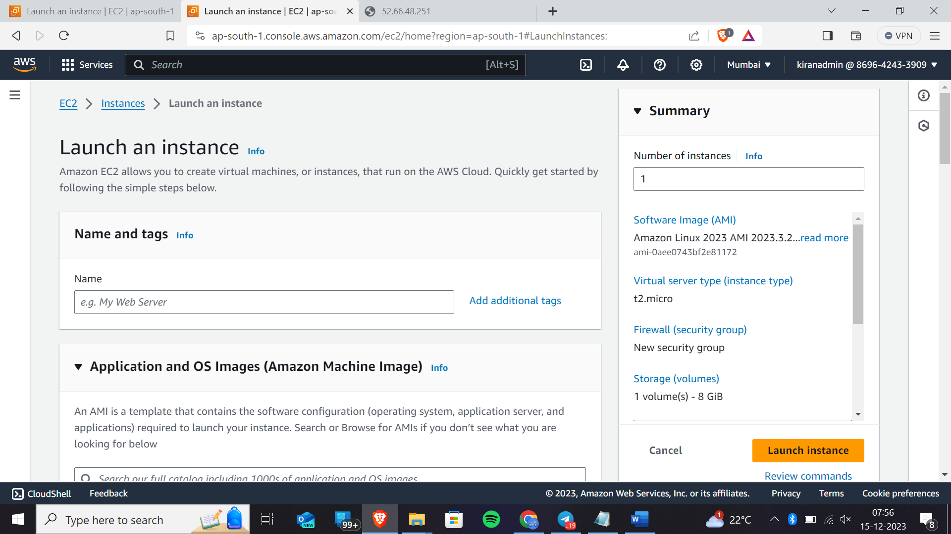Name and tags are your wish you can give or leave it

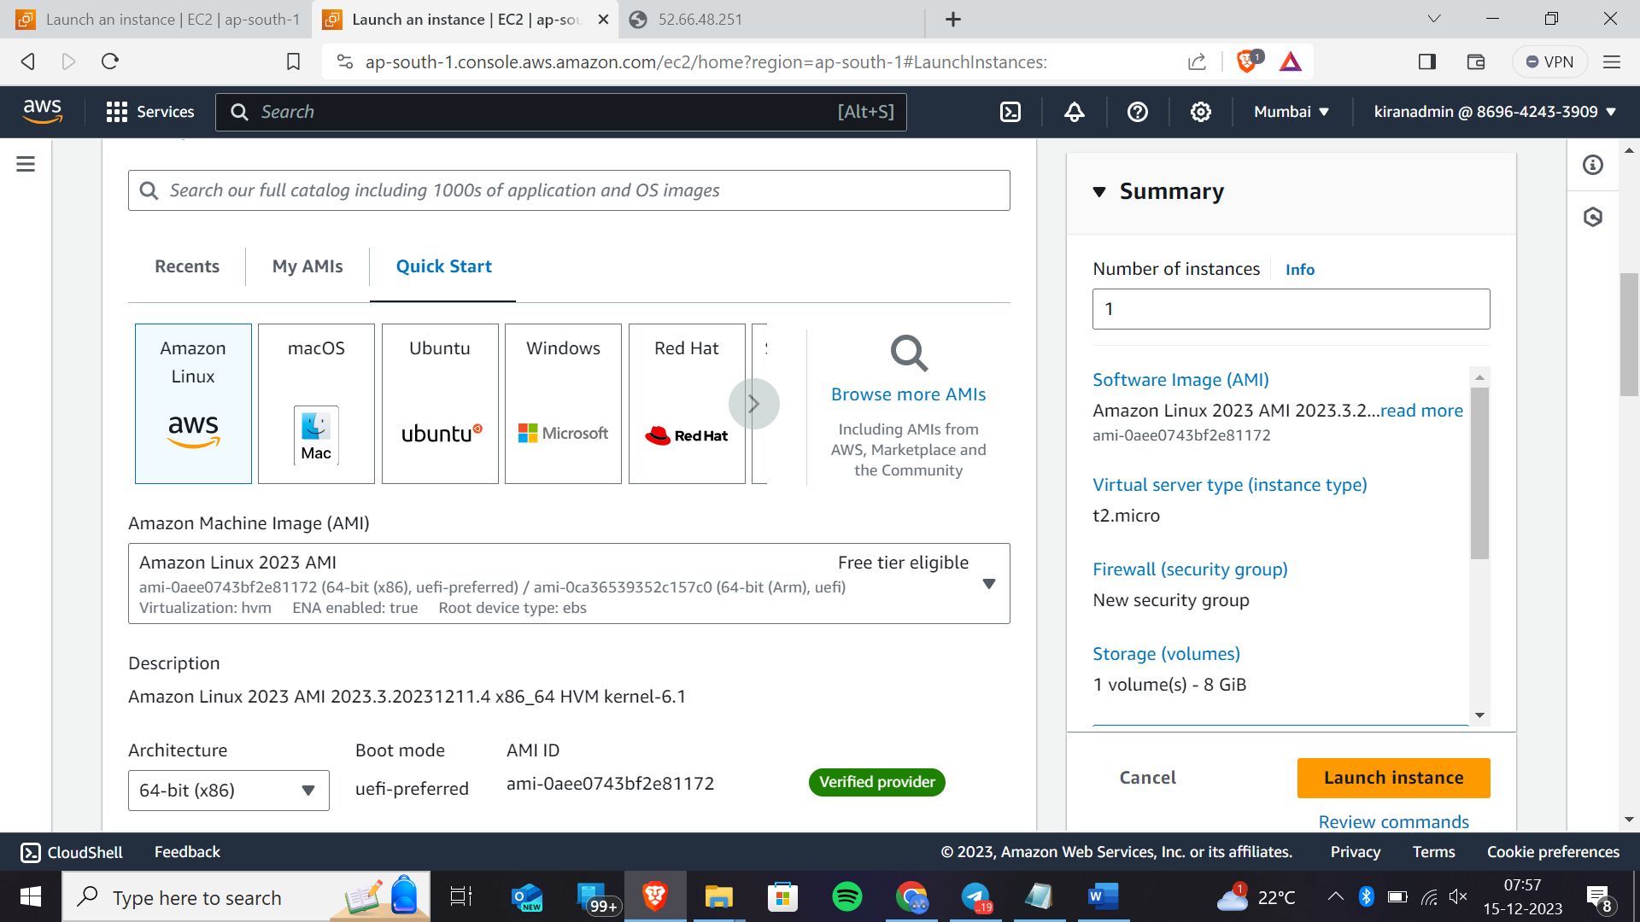select amazon linux

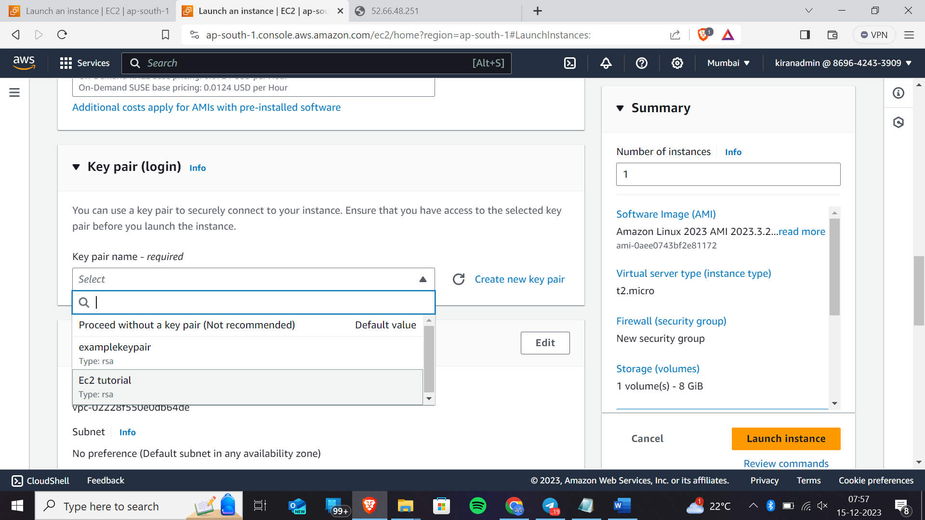select default keypair name

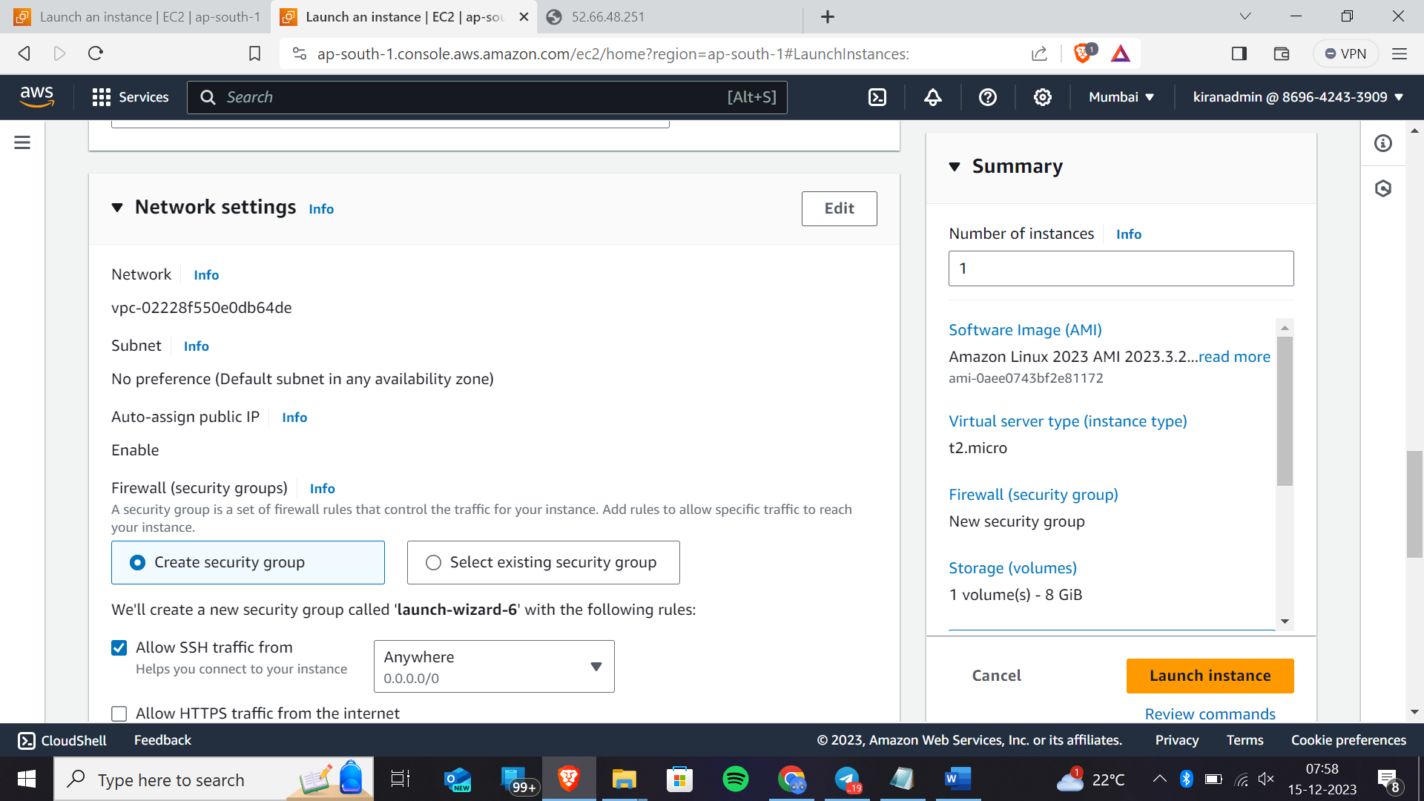In network settings select existing security group

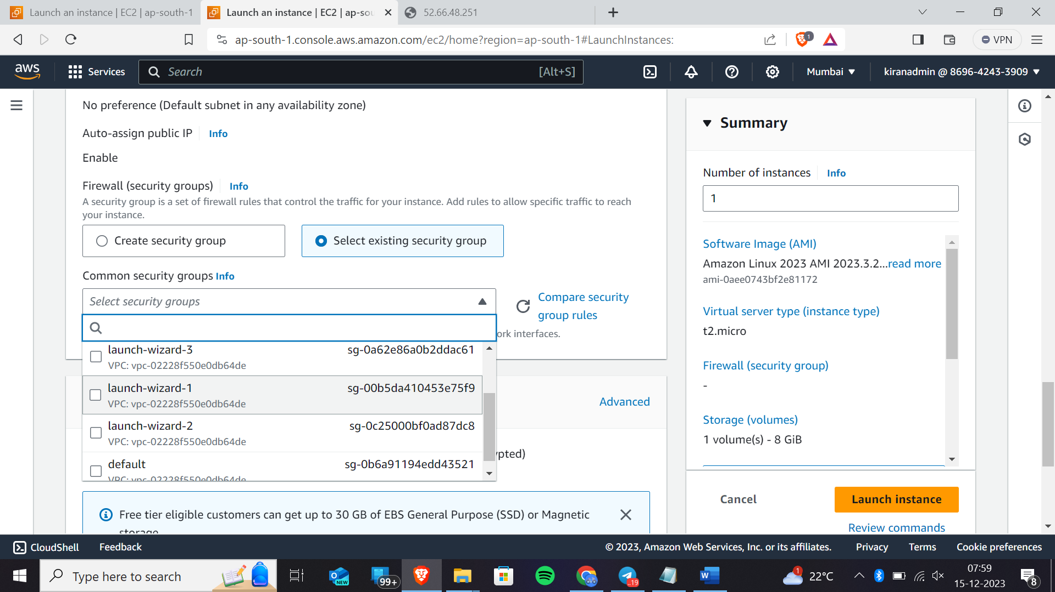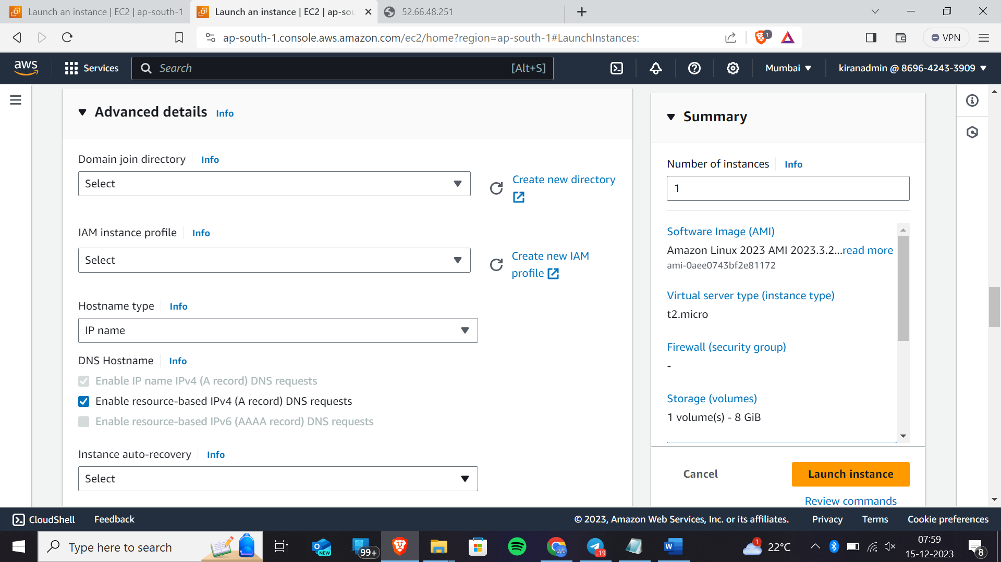In “ADVANCED DETAILS” don’t select any one go to last i.e where you can write comments,scripts here as shown in screenshot

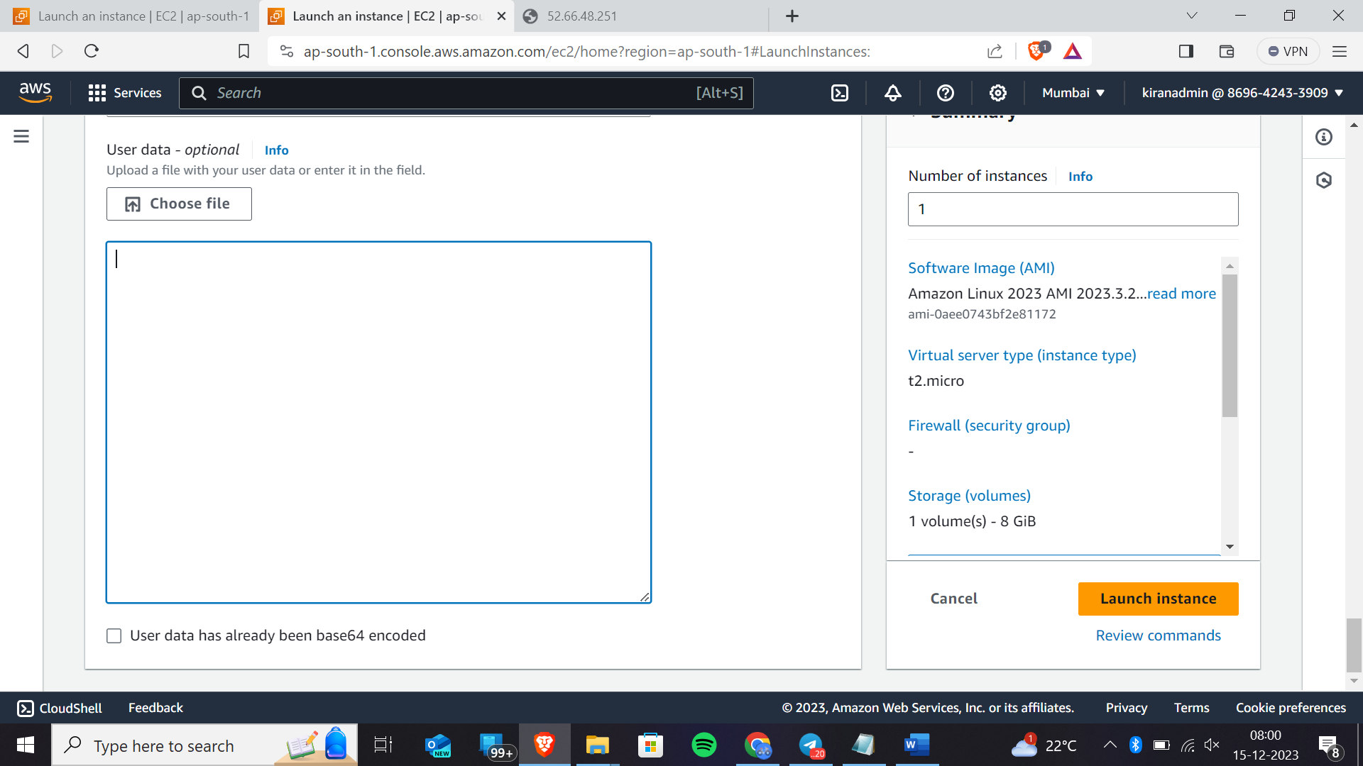

Now write the script that we have written here

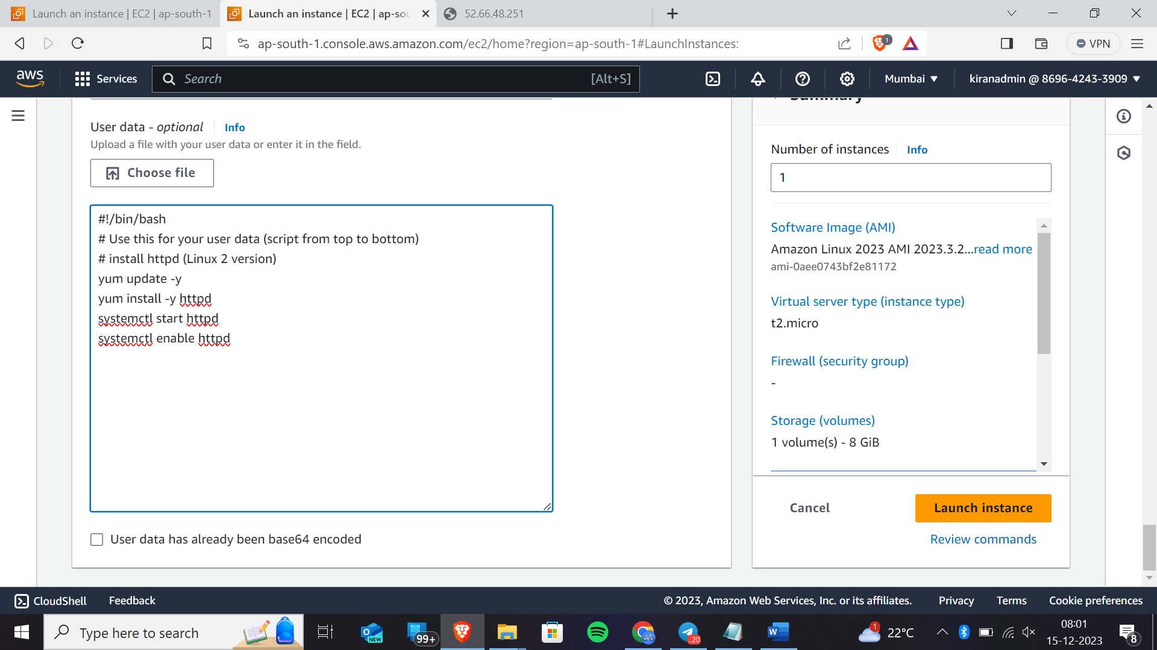These are for installing certain httpd

And now go to next step

Now click on launch instance

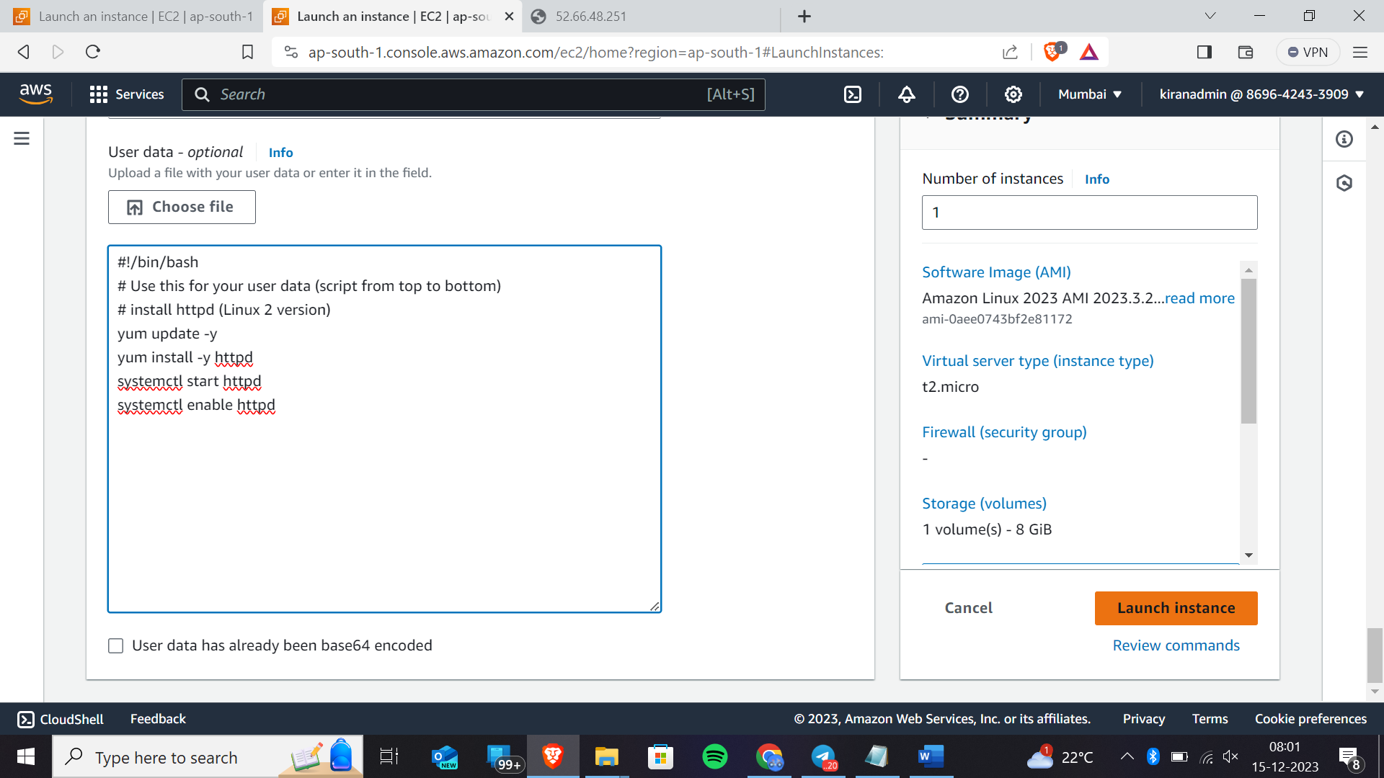

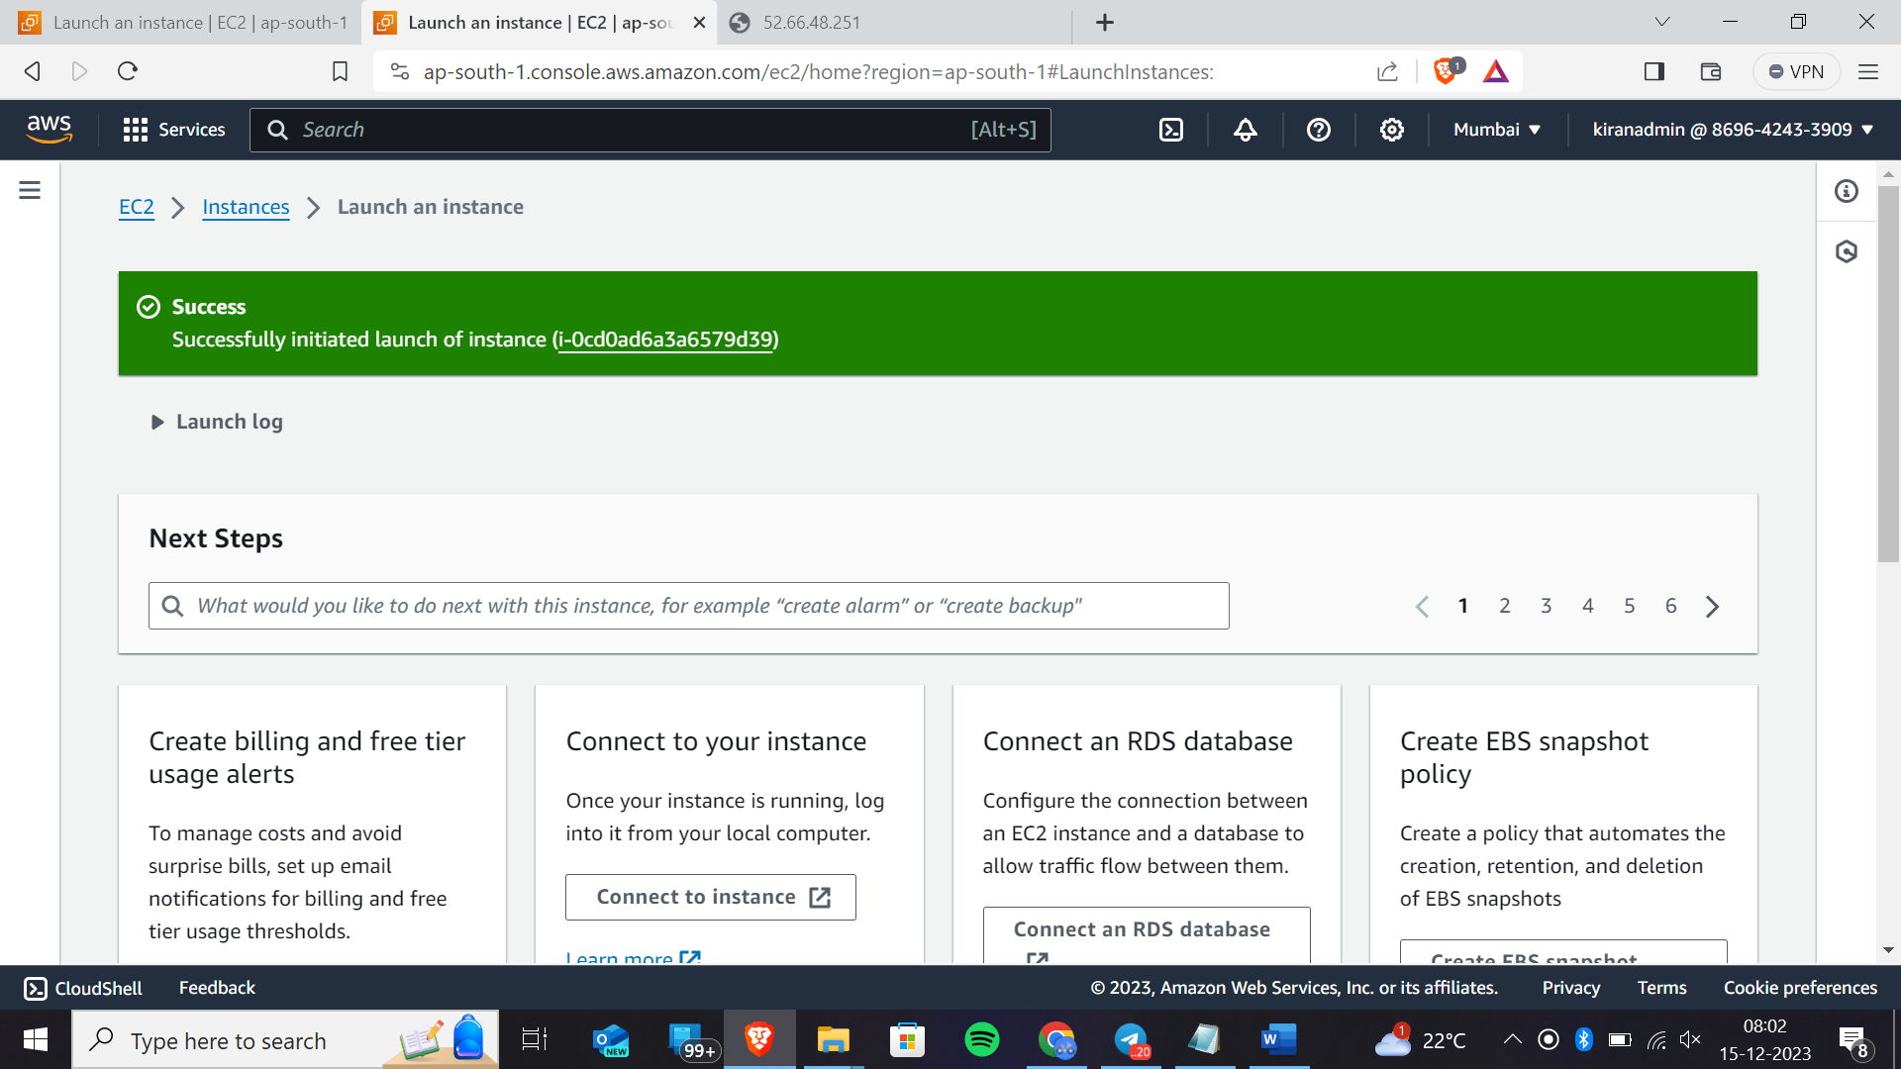Here we have successfully launched an instance

Now go and check in instances

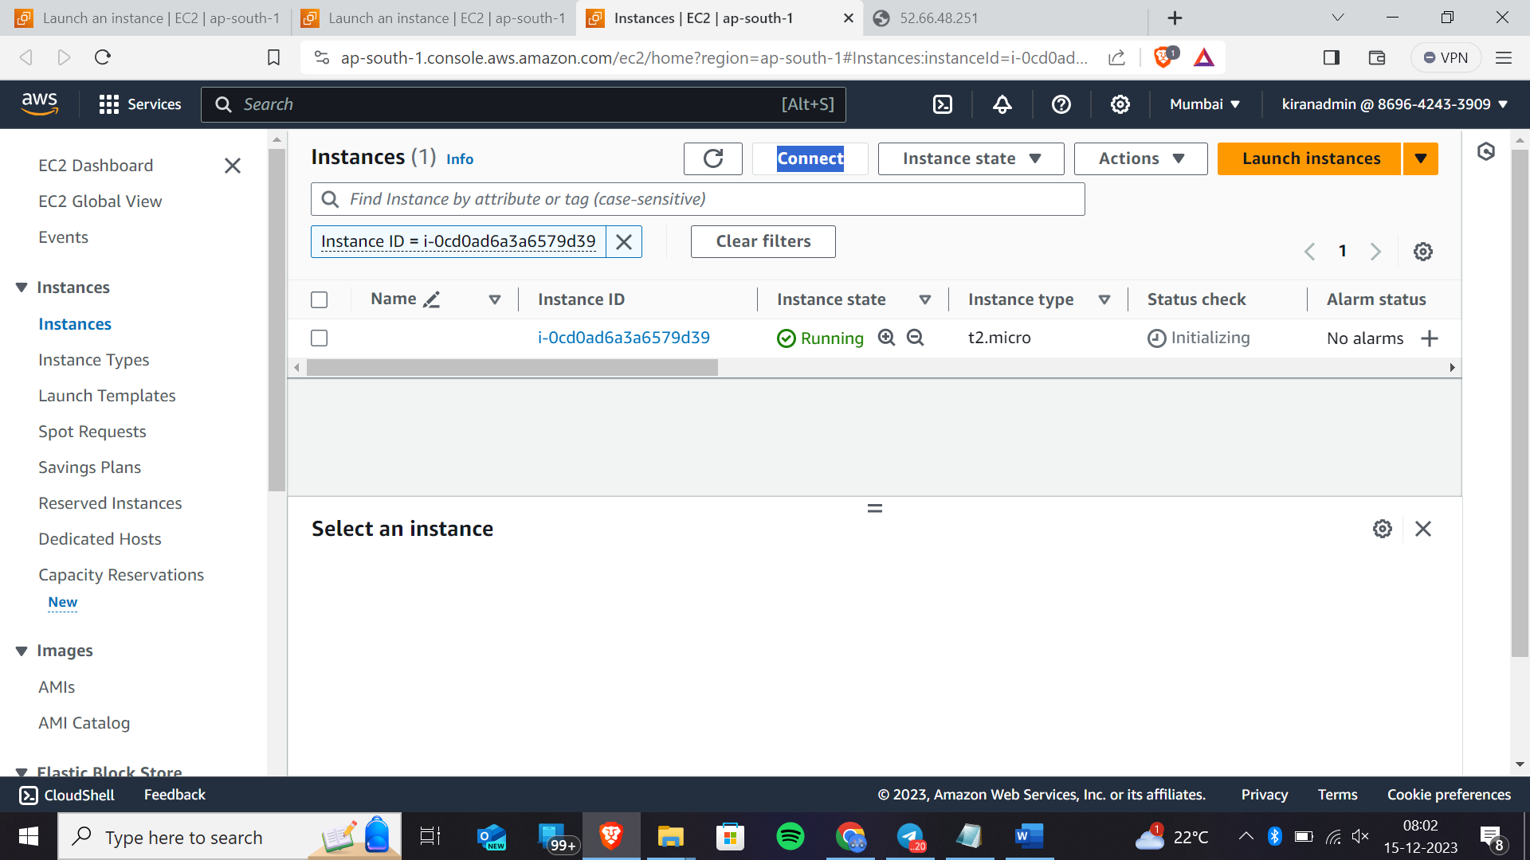The instance that we have launched

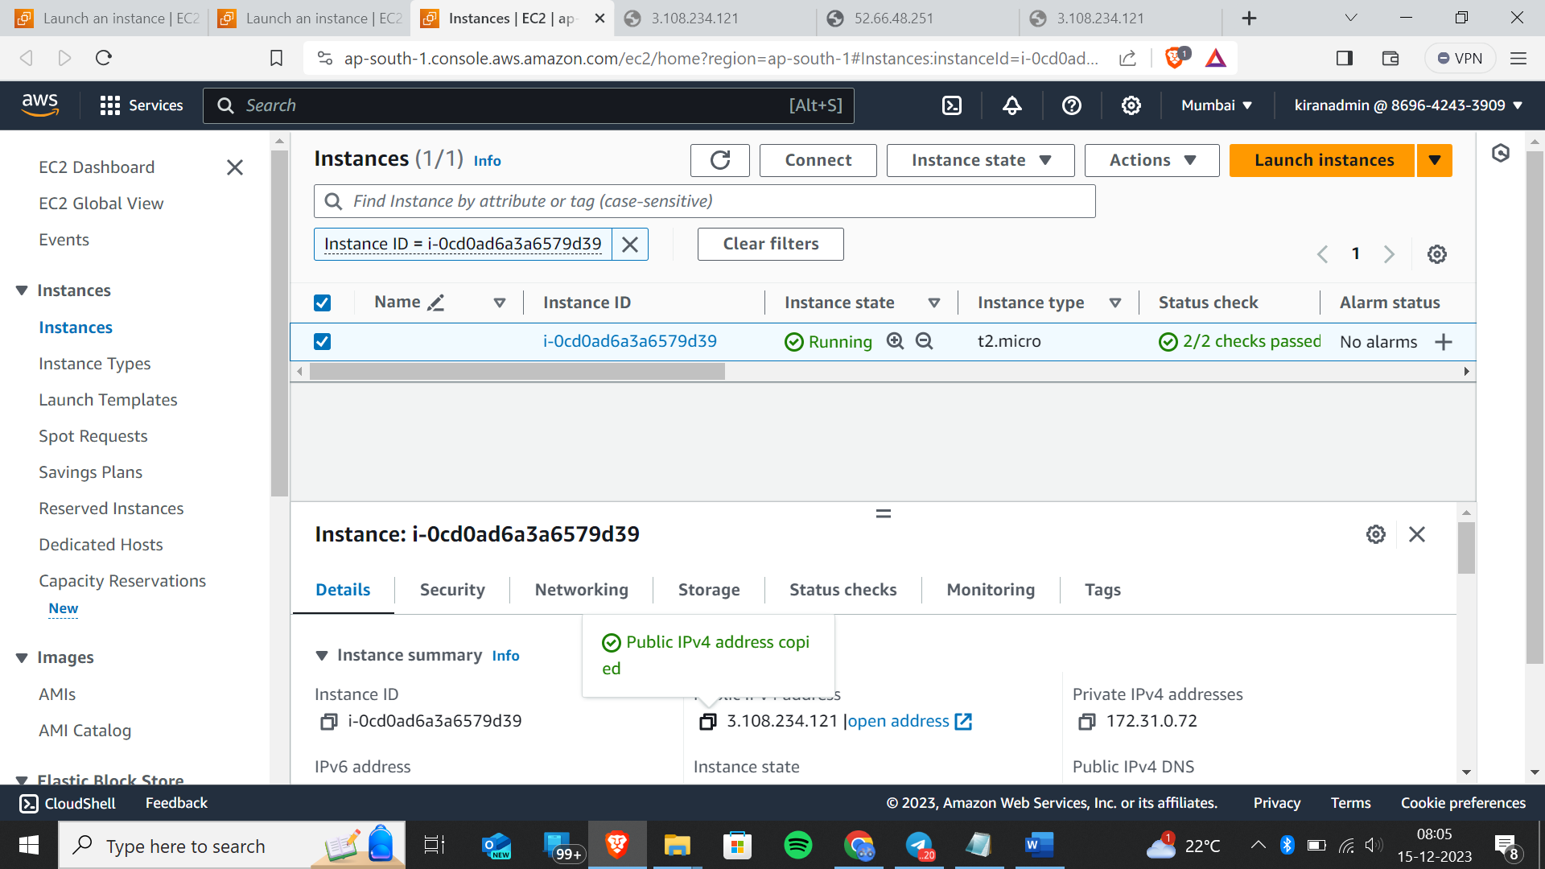Now go to details in the instance and copy the public ip address

And now paste this in the another tab with http”//public ip address(http:// 3.108.234.121) In this format

You will get the page like this

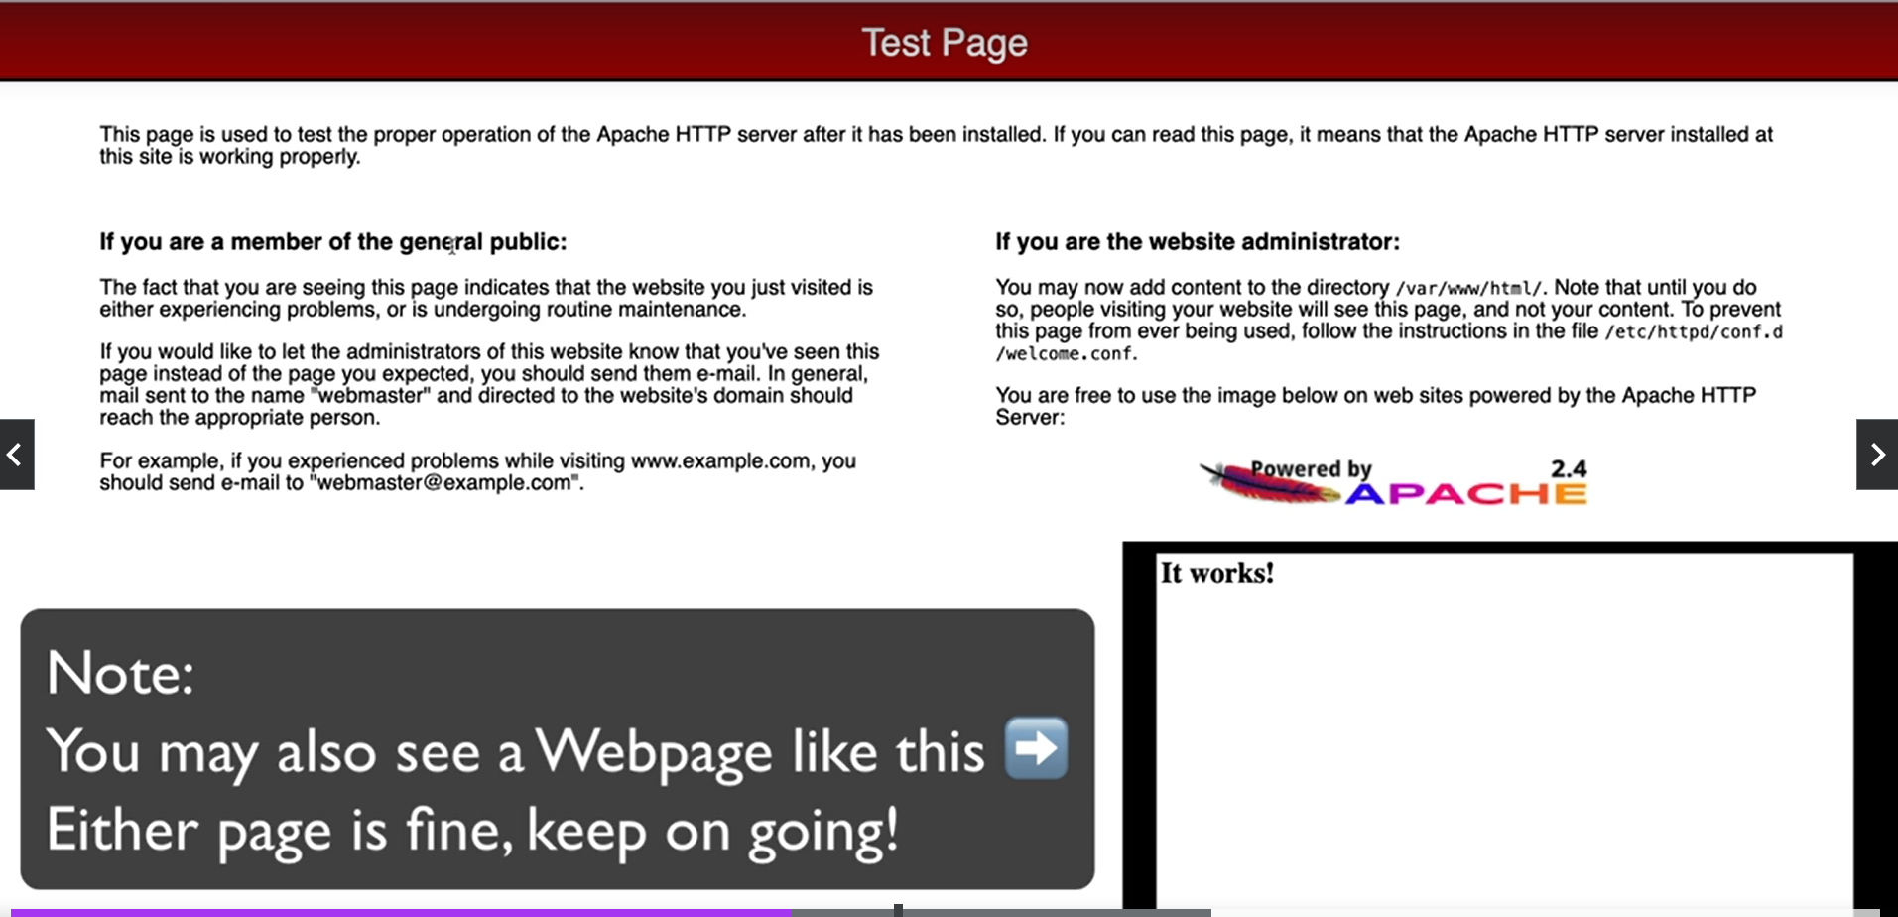Now rightclick on instance you will get like this

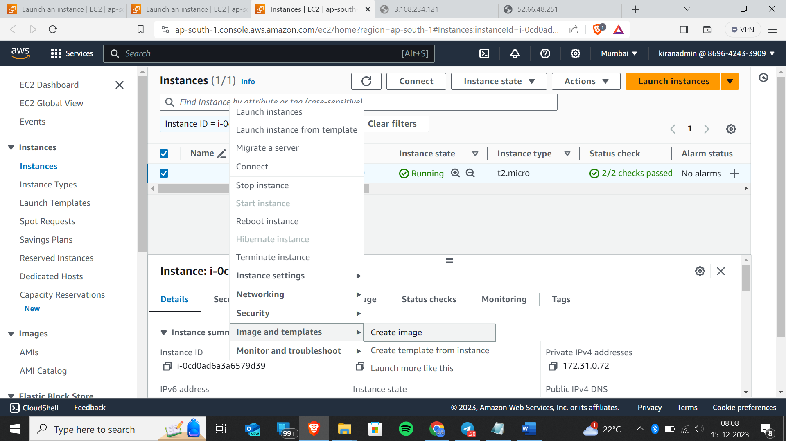Goto image and templates 🡪create image

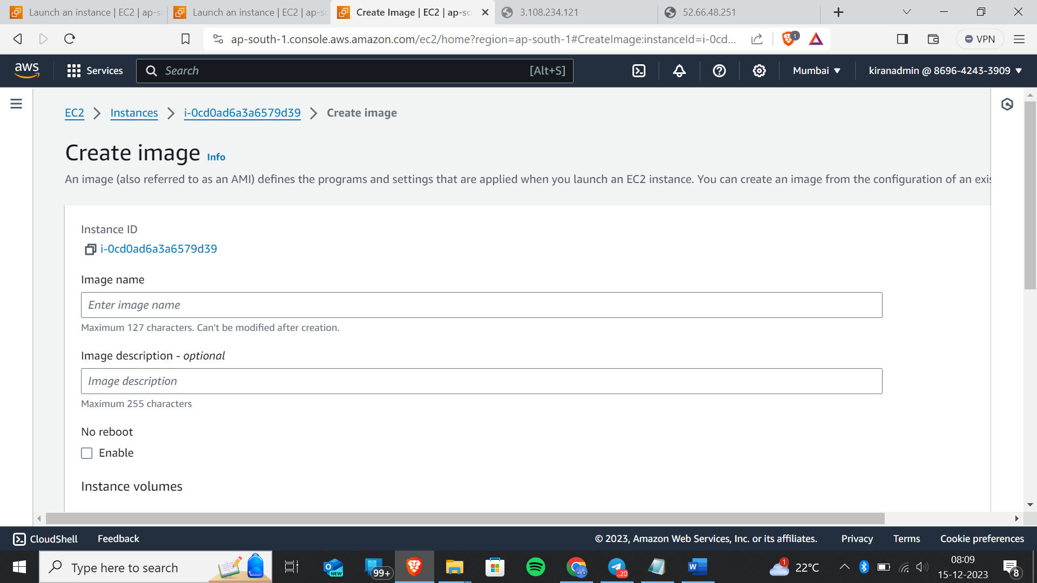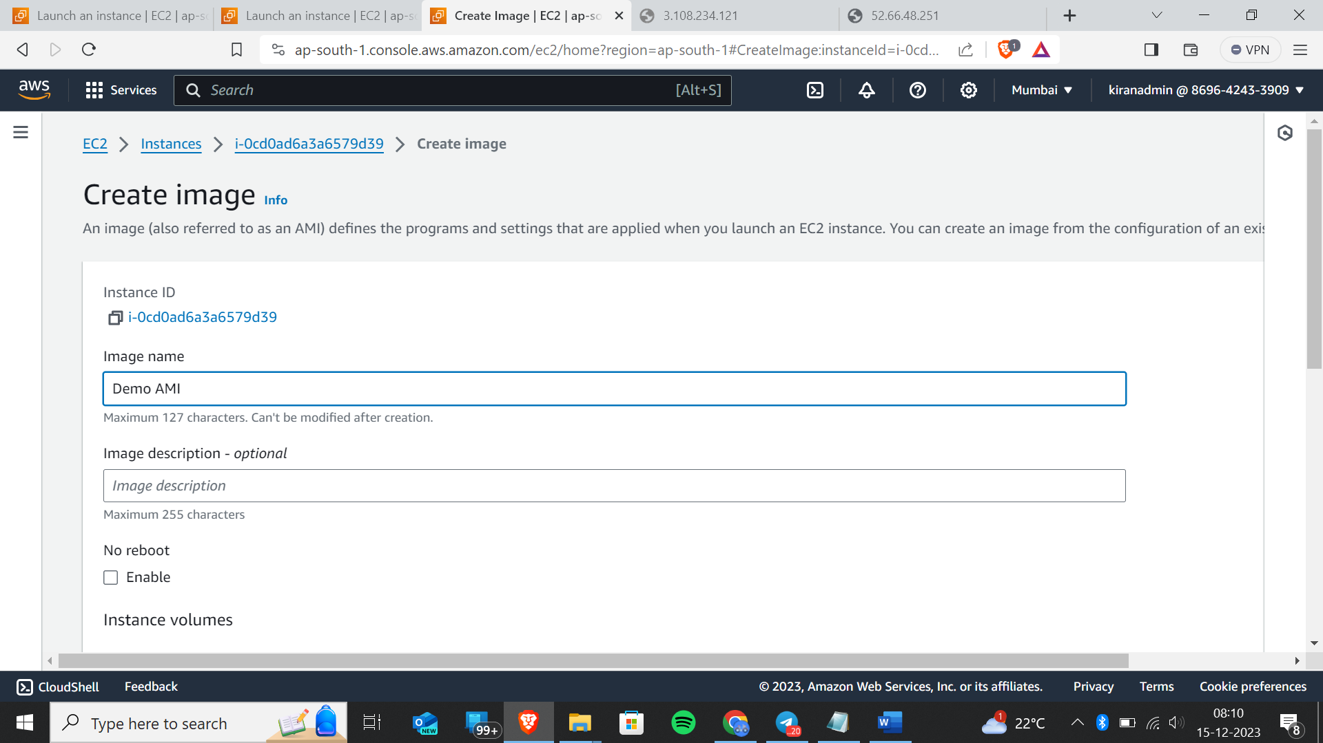Now create image

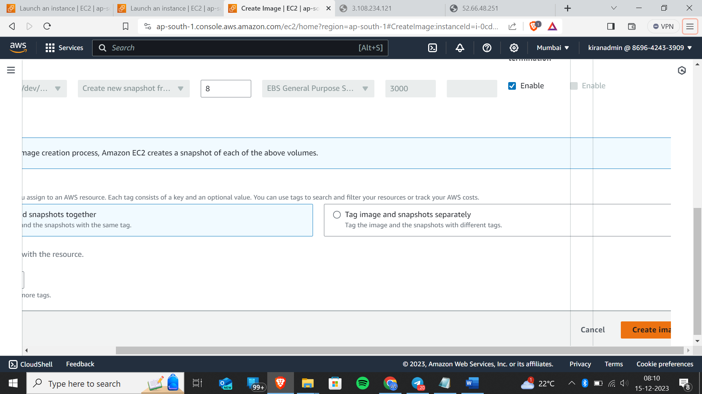

Now click on three lines which is there in the left side

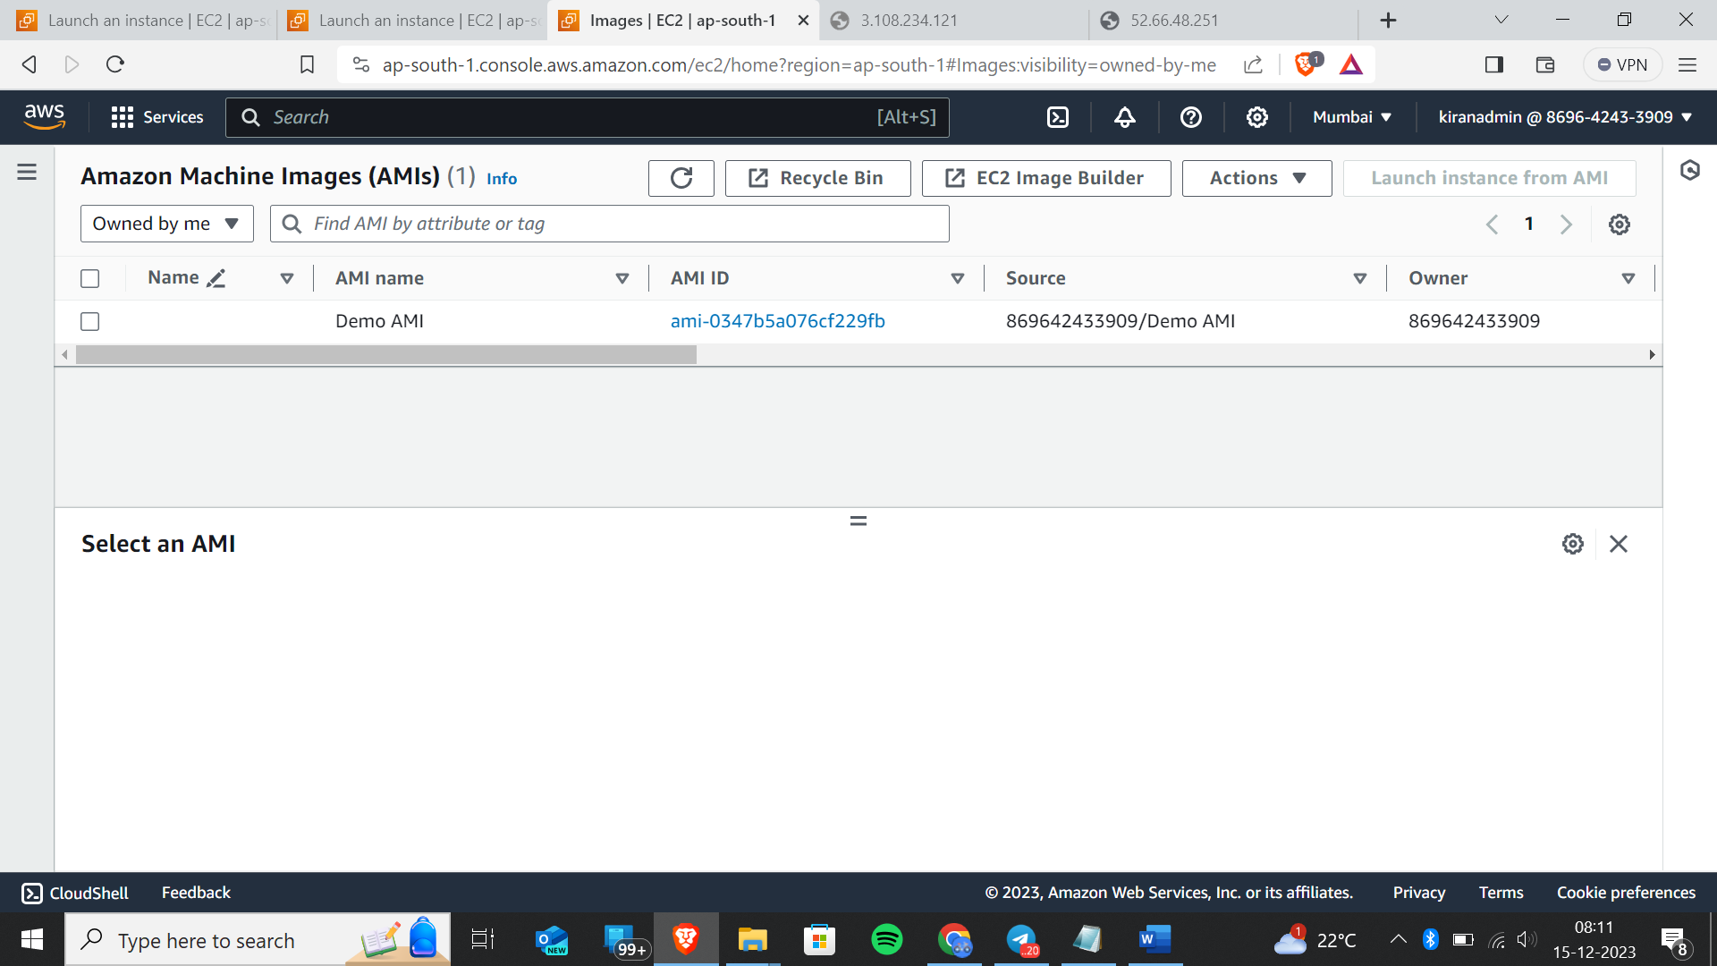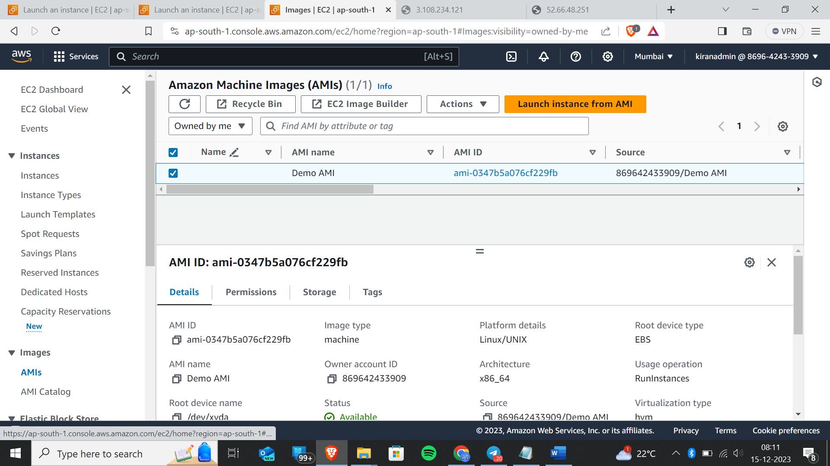Now click on “Launch instance from AMI”

## Application and OS Images (Amazon Machine Image)

  Info

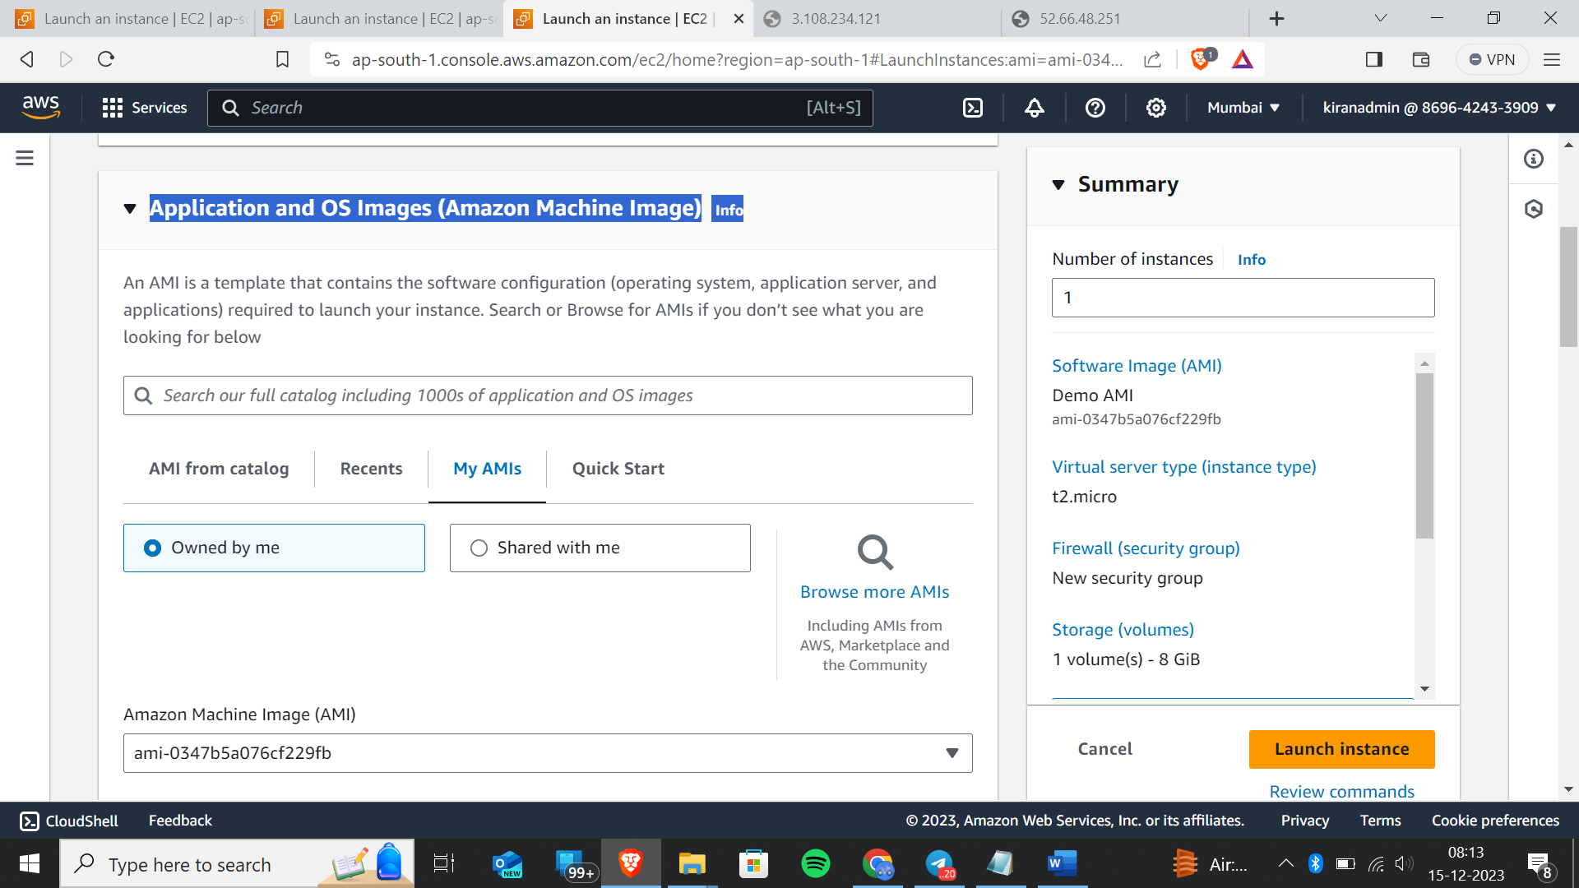

Select MyAMIs🡪owned by me

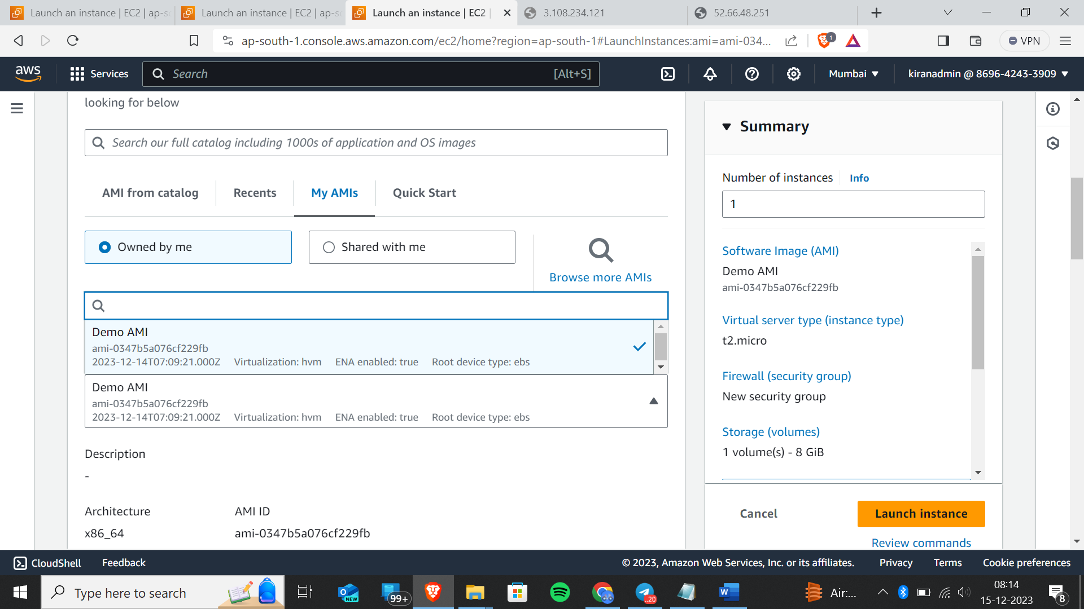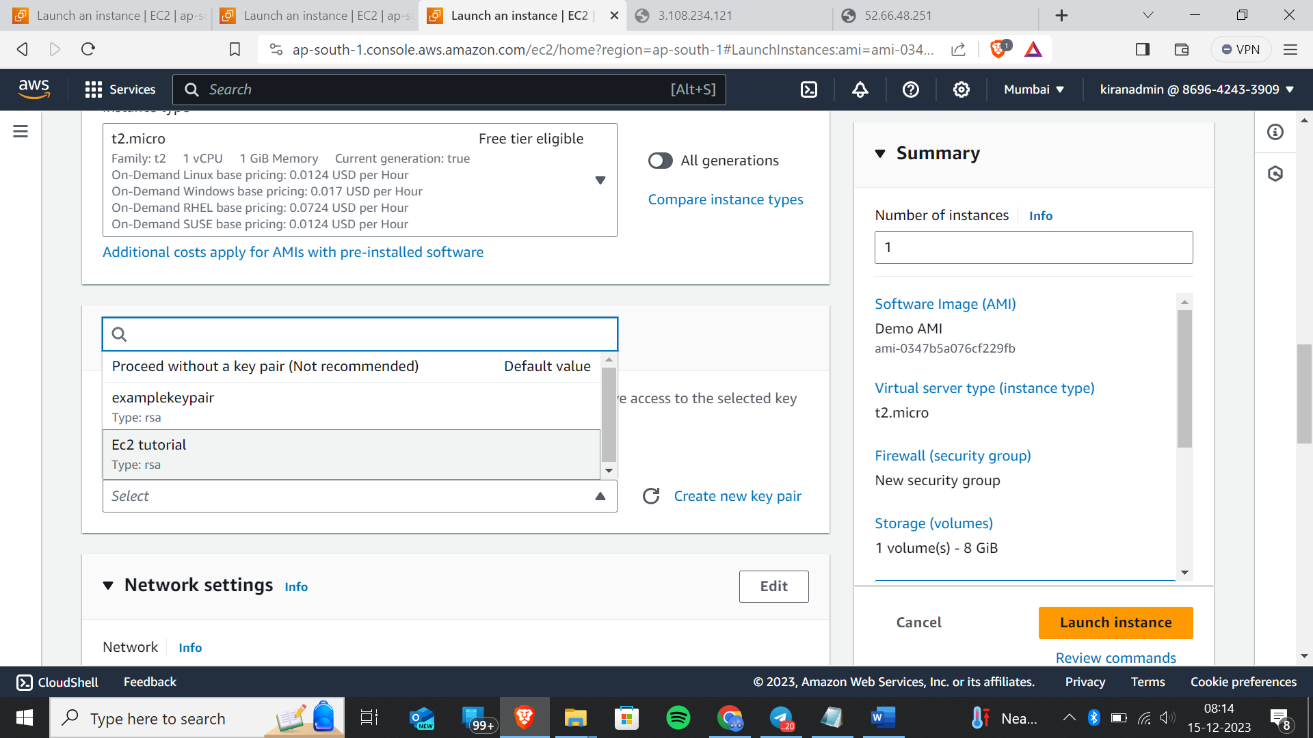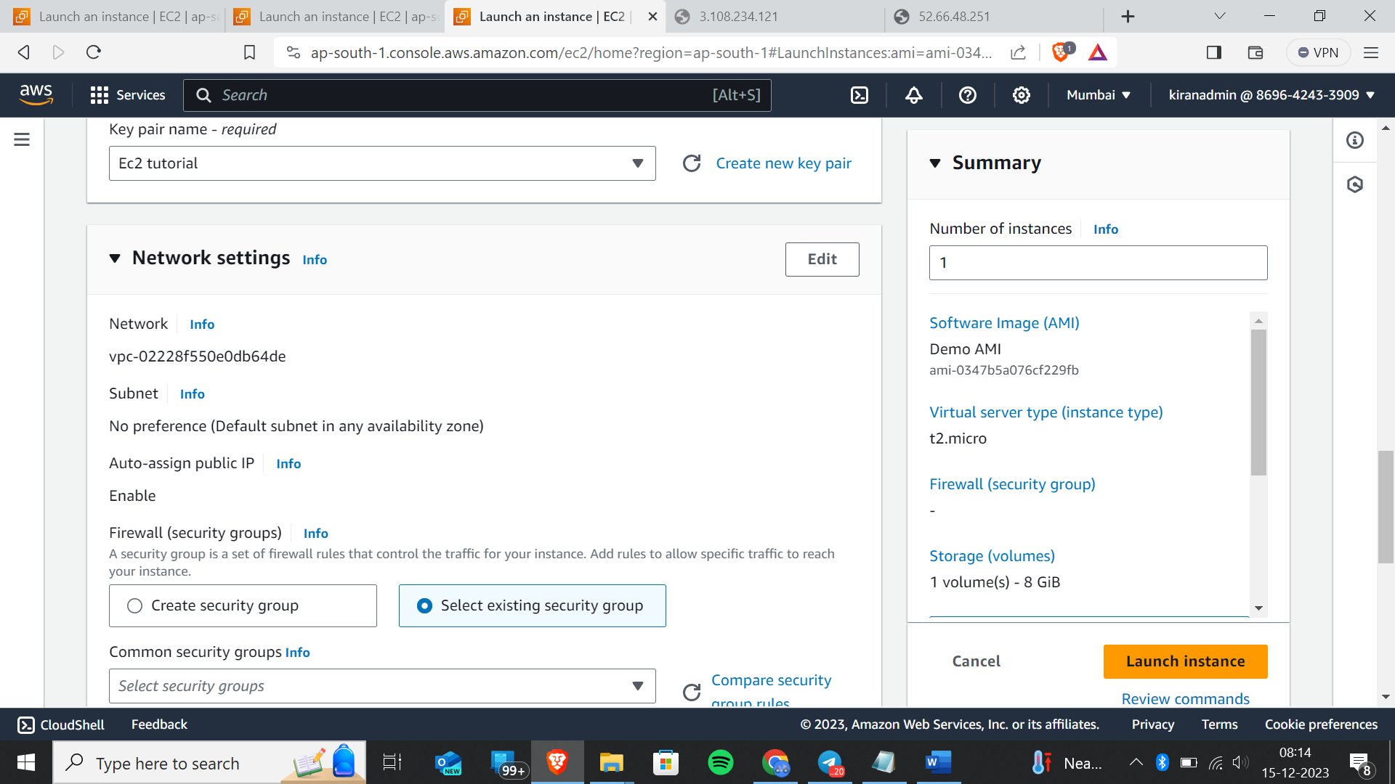select any security group by default

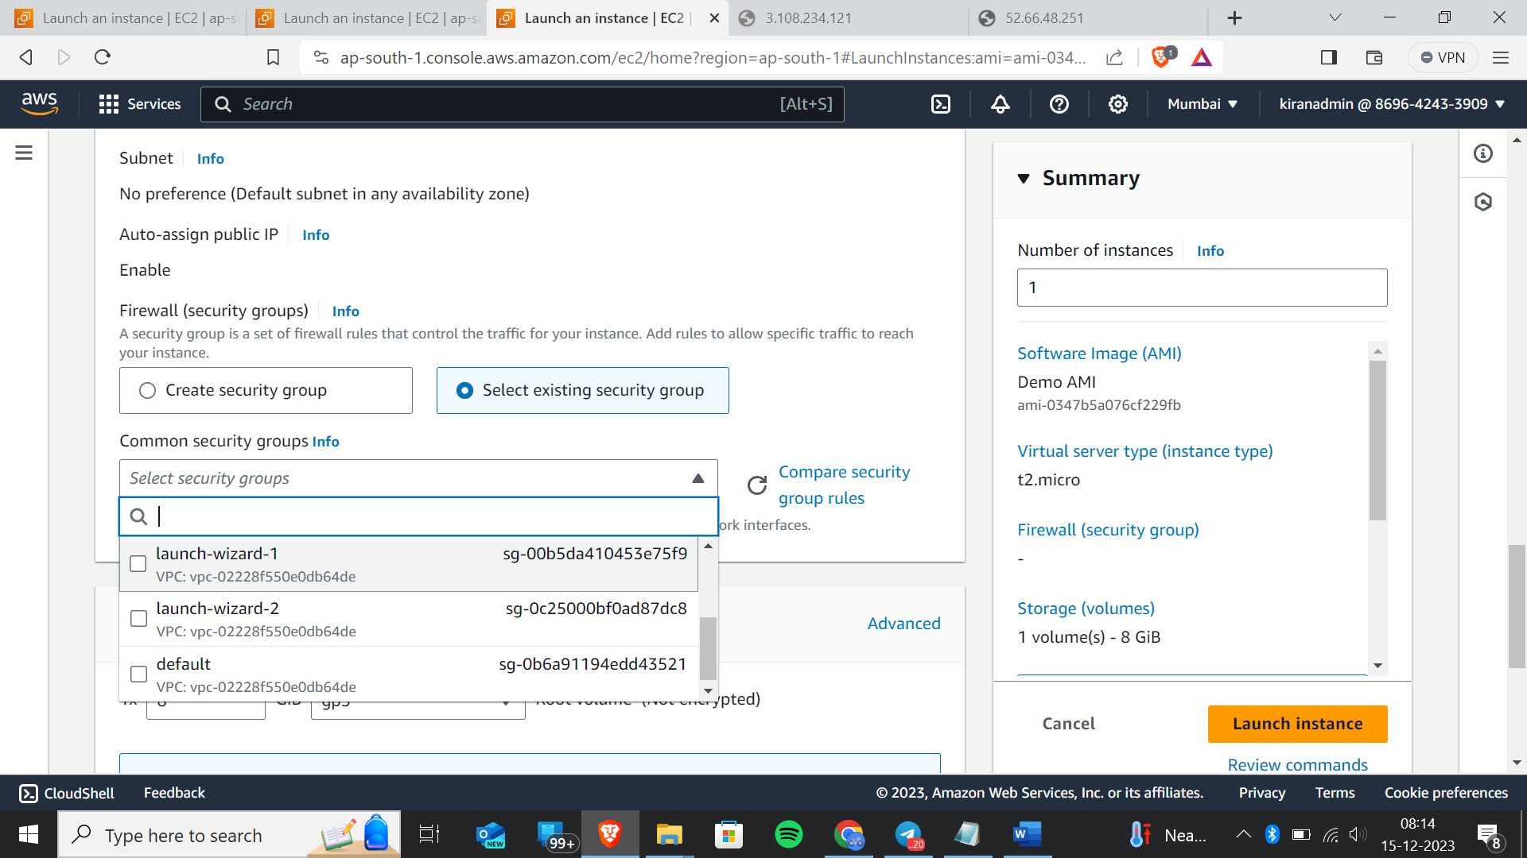

In advanced settings,

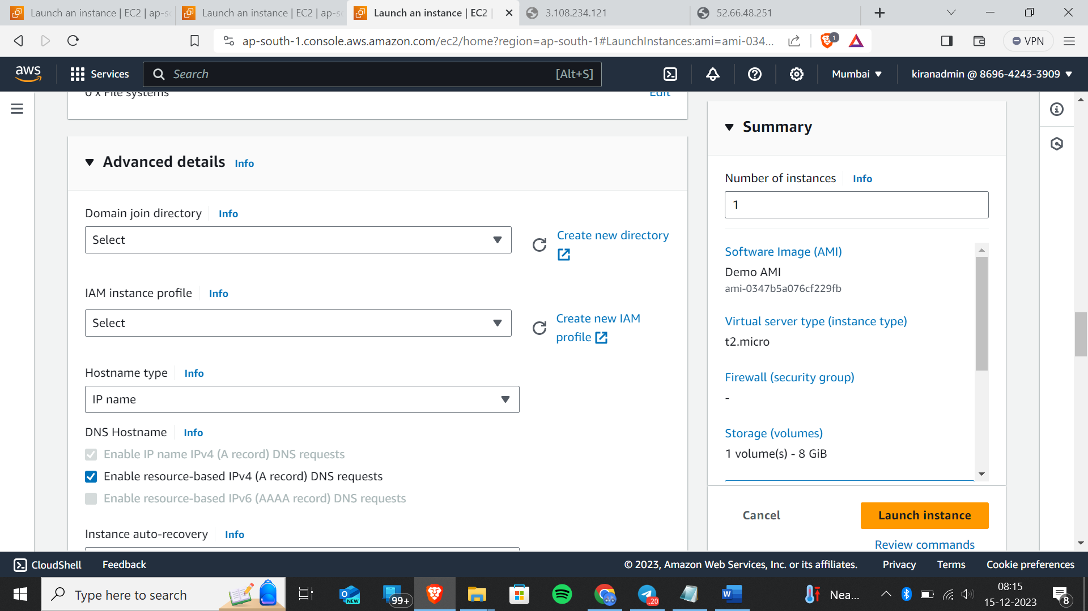

Type this script

#!/bin/bash

# Use this for your user data (script from top to bottom)

# install httpd (Linux 2 version)

echo "<h1>Hello World from $(hostname -f)</h1>" > /var/www/html/index.html

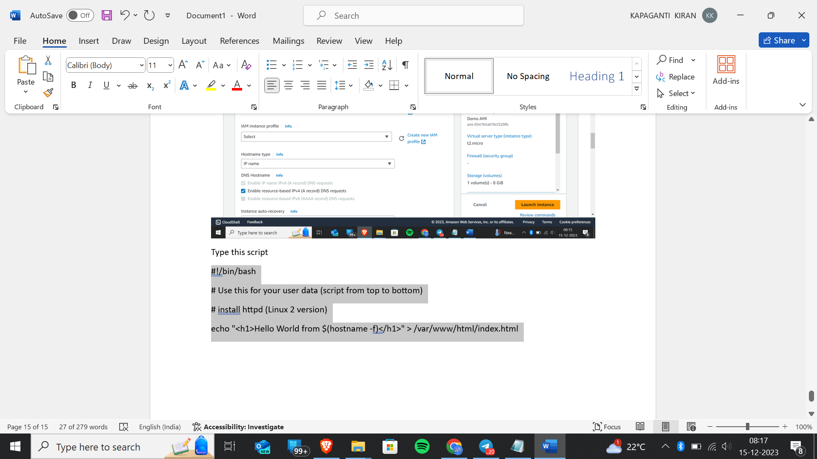

Now click on launch instance

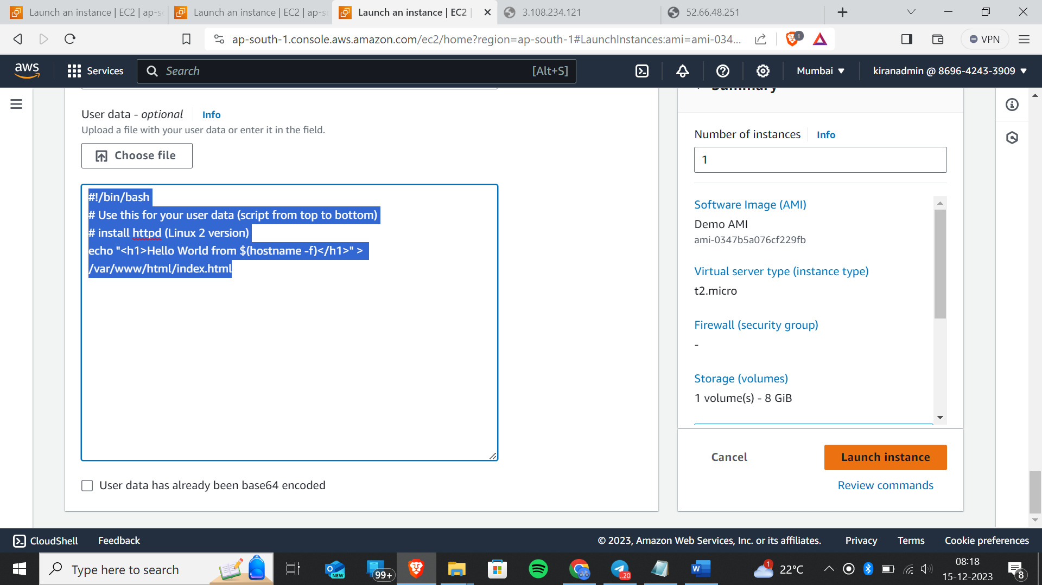

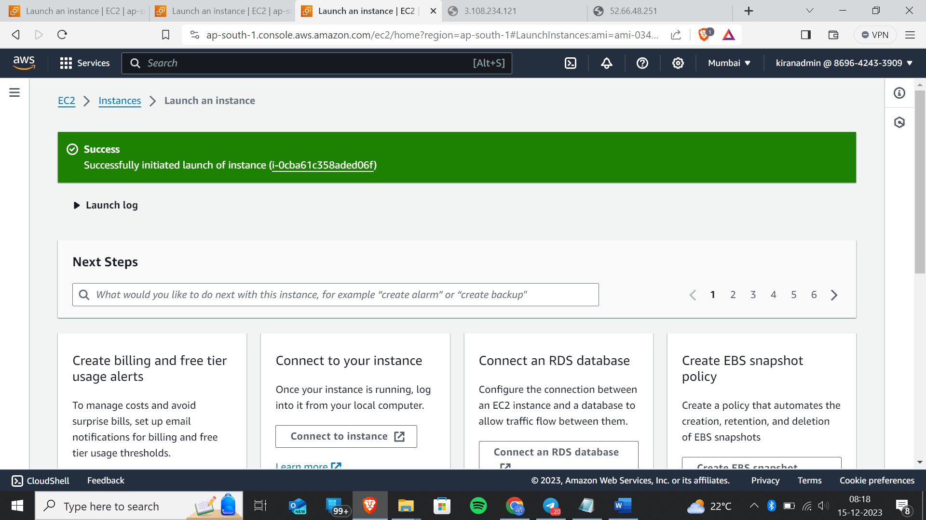we have successfully launched

Select that instance and copy public ip address

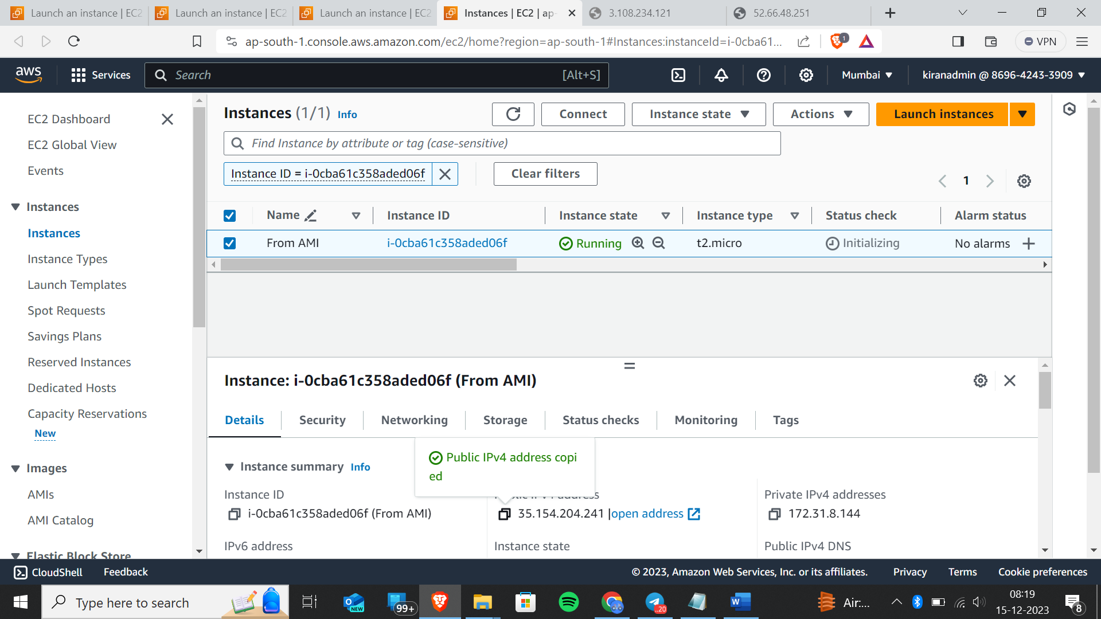

Copy ip address and paste it in the new tab

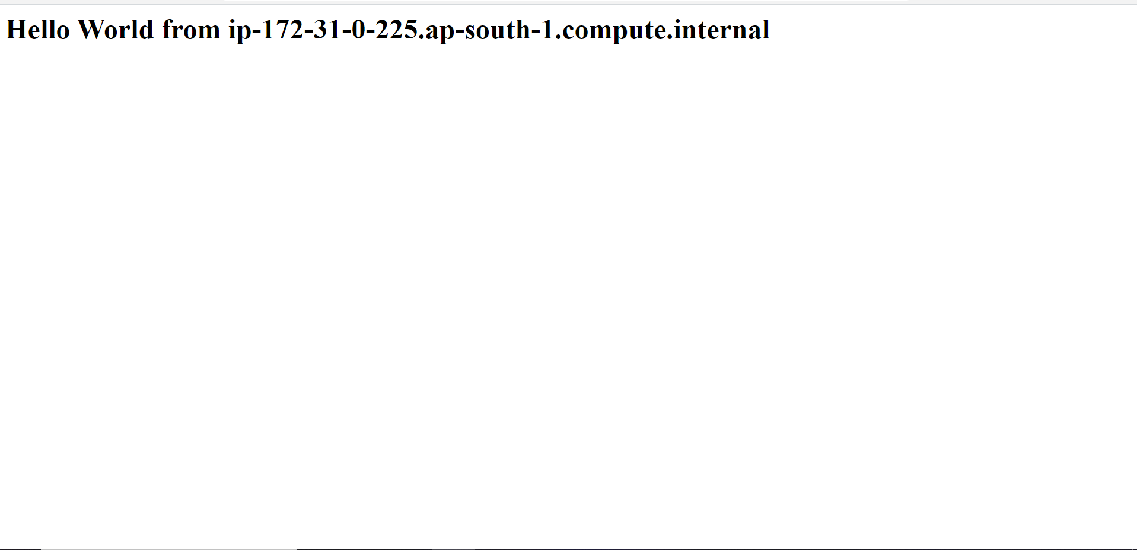you will get this page

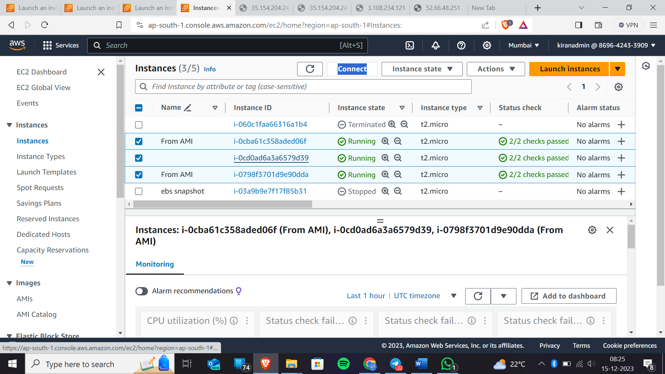Now terminate the selected instances

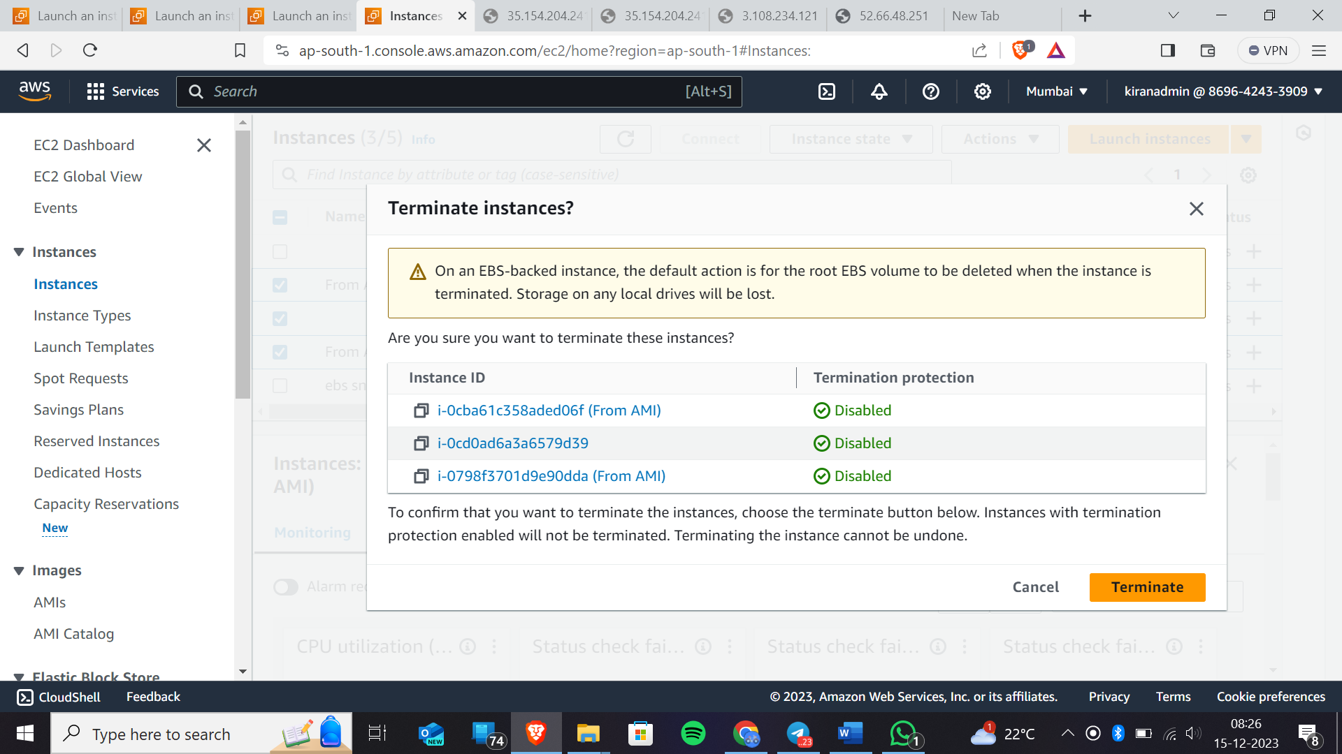

Therefore , this experiment is completed